Relational awareness measure (RAM)– process of development
From Steve Potter and Siobain Bonfield
(Contact Stevegpotter@gmail.com siobainbonfield@yahoo.com)
July 8th 2020
Coding instructions for expert panel
Dear Colleague
Please help us develop a robust measure of relational awareness as defined below. We have a long list of 27 questions which we have derived through several iterations and a previous expert panel consultation. We now want to see if we can achieve a consensus view of two to three questions that point to each of the nine items in the relational awareness grid marked out below. Our further aim is to validate the measure with a large group of therapists in relation to comparable measures in several countries where CAT is practiced.
Introduction
We have been through various stages (process of research paper attached for reference) in developing a measure of relational awareness. This is mainly in the context of team training, reflective practice and individual therapy. RAM is a contextual measure of our relationships simultaneously within ourselves, between ourselves and others interpersonally and intersubjectively and with the world of society and culture around us. The measure has arisen out of the versatile use of relational mapping derived from the concept of reciprocal role procedures (Ryle and Kerr 2002, 2020, Potter 2020) We would greatly appreciate your independent evaluation of the tie in between items on our relational awareness grid and the fit between each item and questions from the long list of questions. We are aiming for a questionnaire of nine or eighteen questions and with each question pointing principally to one item (some may also point, less strongly, to others items in the grid). Please familiarize yourself with the short description of relational awareness and the grid and accompanying items descriptions before going through the questions.
What is relational awareness?
Relational awareness is an active, dynamic intelligence that we co-create afresh in each situation. It is the awareness we yearn for, in trying to orchestrate and manage ourselves in the twenty first century individually and collectively. The qualities of relational awareness work simultaneously in and across many dimensions of interaction which can be clustered as follows:
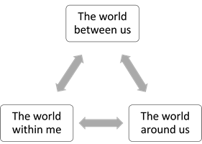
- Within us we have a world of mind, brain, and sensory connections in and through our bodies, along with the memories and stories we carry forward from the past into the present and the future. It is a dynamic world inside us with the push and pull of unconscious and conscious processes acting intentionally and automatically.
- Between us we have the space of an interpersonal encounter through shared behaviour, role reciprocations and the orchestration of meeting person-to-person in search of meaning, validation, and care.
- Around us we have the groups, the joint activity of language, the shared stories, power dynamics, cultures, and institutions of society in a simultaneously local and global context.

Qualities and dimensions of relational awareness
The main qualities of hovering, shimmering, mapping, storying, processing, and negotiating have already been discussed in part one of the book and are applied in part three of the book. These qualities combine with the three dimensions (summarised in the preceding section) to create a grid of nine elements of relational awareness. These are described in the following list and their place in the grid highlighted in the table below. They make up a palette of relational ‘colours’ or an orchestra of relational ‘instruments’ for recomposing and re-orchestrating awareness.
- Reflection and self-understanding: Being able to independently hold in mind the orchestration of different ideas, life stories and points of view with compassion and curiosity. Seeing links between past, present, and future and exercising personal judgement.
- Dialogue and debate in sharing ideas: A capacity to negotiate and navigate each other’s views and beliefs and reach an understanding that fits mutual tasks and creates space and perspective for more than one story, strategy, or truth.
- Curiosity about values, systems and societies: The resources and the ability to keep making sense of the complex world around in the context of diverse lives, cultures, and systems of social power. Ability to discern ideology and propaganda from thought and theory and see self and others in and out of role in society.
- Ambivalence and authenticity: A capacity to accept, assert and value truths within us whilst tolerating ambivalence and the simultaneous presence of contrasting and conflicting feelings. A sensitivity to the push and pull of feelings with others through their resonance within us.
- Empathy and involvement: The capacity to share involvement and interact appropriately with each other’s feelings without being swayed into one state of mind for long unless it is jointly chosen. A feeling for changes in mood and moment, harmony and disorder. A curiosity about the retelling and the re-orchestration of each other’s life stories.
- Feel the diversity and power of us and them: A feeling for, and openness to, cultures and society in a global context wherein multi-local and universal forces and themes interact. Compassion and curiosity for what is felt to be fair and not fair based on the ability to put oneself in the shoes of others in the world without losing a personal identity or depriving others of a freedom of identity.
- Taking part in role with self-control and expression: The ability to choose and act, to do things with a mix of self-restraint and expression in a way that orchestrates the parts, the roles and the whole sense of self as a person. Knowing when to hide self behind a role by living with a divided sense of self and managing by appearances.
- Co-creative work and activity: Being flexible and inventive and able to act together in a focused and sustained way to make things whether practical or artistic, personal, or collective. Recognising and valuing the process and story of this shared labour and productivity. Delighting in seeing something jointly achieved and mutually owned and attributed. Respect and gratitude for these qualities in others.
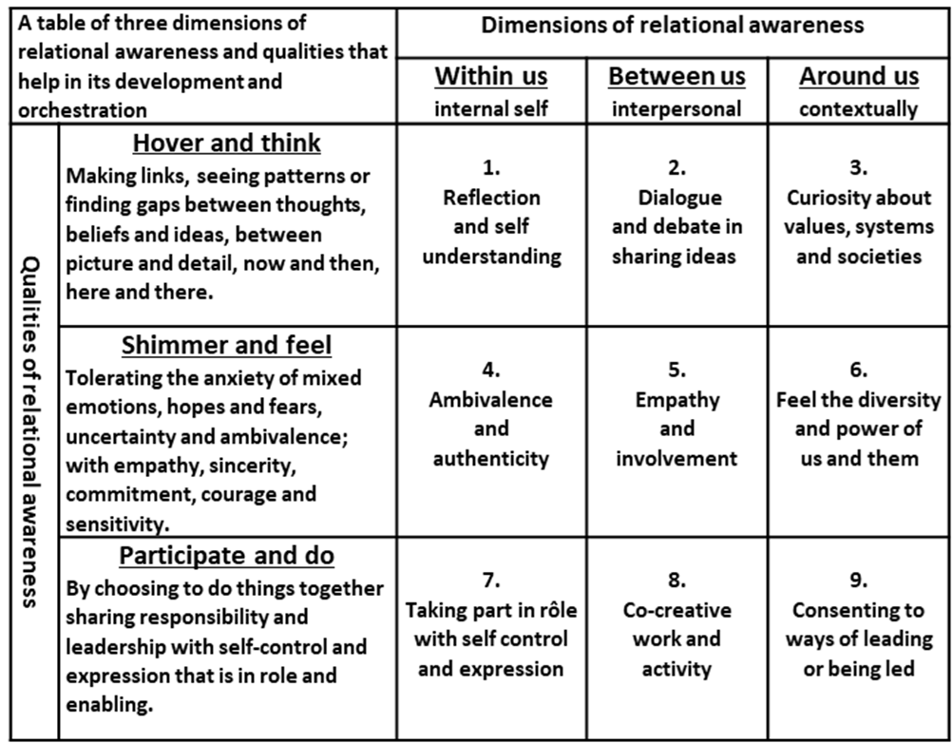
- Consenting to ways of leading and being led: Knowledge of leadership and organisational roles, and how to participate as leader or follower in and out of role, formally or informally. A capacity for a democracy of ideas and feelings in co-operation with others and systems in society. A culture of mutual aid in helping each other contribute.

Panel exercise
This long list of questions has been agreed through several iterations with the researchers with the intention of three questions pointing strongly to one item in the grid. We also wish to identify the strongest item of the three. Please indicate in order of strength, in your view, which grid items each question is pointing or linking to most strongly. If you think the question points to another item less strongly put its number in the second column and then if a third link put it in the third column. Repeat the exercise for every question. Where you cannot see a second or third choice of connection for a specific question then mark the second and third choice boxes with an x. Question 1 is a made up question to offer an example of how to complete the research exercise. Many thanks for your help and send your results as an attachment by email to stevegpotter@gmail.com
 | Long list of questions | Grid 1 item score | Grid 2 item score | Grid 3 item score
 | I reflect on my thoughts and am keen to understand myself | 1 | 7 | x
 | We like to know what is going on in each other’s lives
 | I have time to work out what I think and feel about things
 | We help each other speak up and voice our opinions
 | The way things are managed is open, clear and honest
 | I have room for mixed feelings and uncertainty
 | We help each other get involved
 | We respect our differences of identity and way of life
 | I can actively and assertively play my part and fulfil my roles
 | We tread carefully over difficult and sensitive issues
 | Work is done side by side with dignity
 | I can take in new perspectives and points of view
 | We take time to plan what to do and evaluate the outcome
 | I can recognise patterns of social discrimination and bias
 | My roles and are acknowledged
 | All our contributions are recognised and evaluated fairly
 | There are times when we are over involved and in conflict
 | I can be true to myself and I feel authentic
 | We look out for each other and show empathy
 | We are aware and tolerant of our differences of background
 | It is okay to feel vulnerable at times
 | I can exercise self-control and stay in role when required
 | I see when to be flexible in my responses and when to be firm
 | We can develop a shared understanding and ways of working
 | We can fit the pieces of the jigsaw together to see the big picture
 | There are transparent, open lines of leadership and management
 | There is openness to change and innovation
 | Solutions are agreed, rather than imposed

